DIY Ventures Sdn Bhd Pre-Onboarding Questionnaire

DIY Ventures Pre-Onboarding Questionnaire
To be completed by client before the first deep-dive meeting

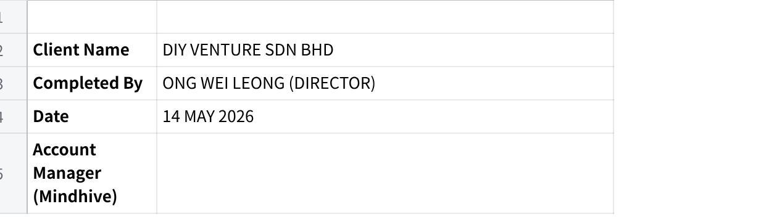
Click the image to view the sheet.

How to Use This Document
This questionnaire collects factual information about your business so we can configure MAIA correctly and prepare for a focused kick-off meeting. The meeting itself will focus on how your workflows actually run and where they break — not on collecting this baseline data.
Guidelines:
- Answer as completely as you can. Partial answers are fine — write "unsure" or "to discuss" for anything unclear.
- For tables, add or remove rows as needed.
- If a question doesn't apply to your business, write "N/A."
- Please return this document within 5 business days of receipt. Your kick-off meeting will be scheduled once this is received.

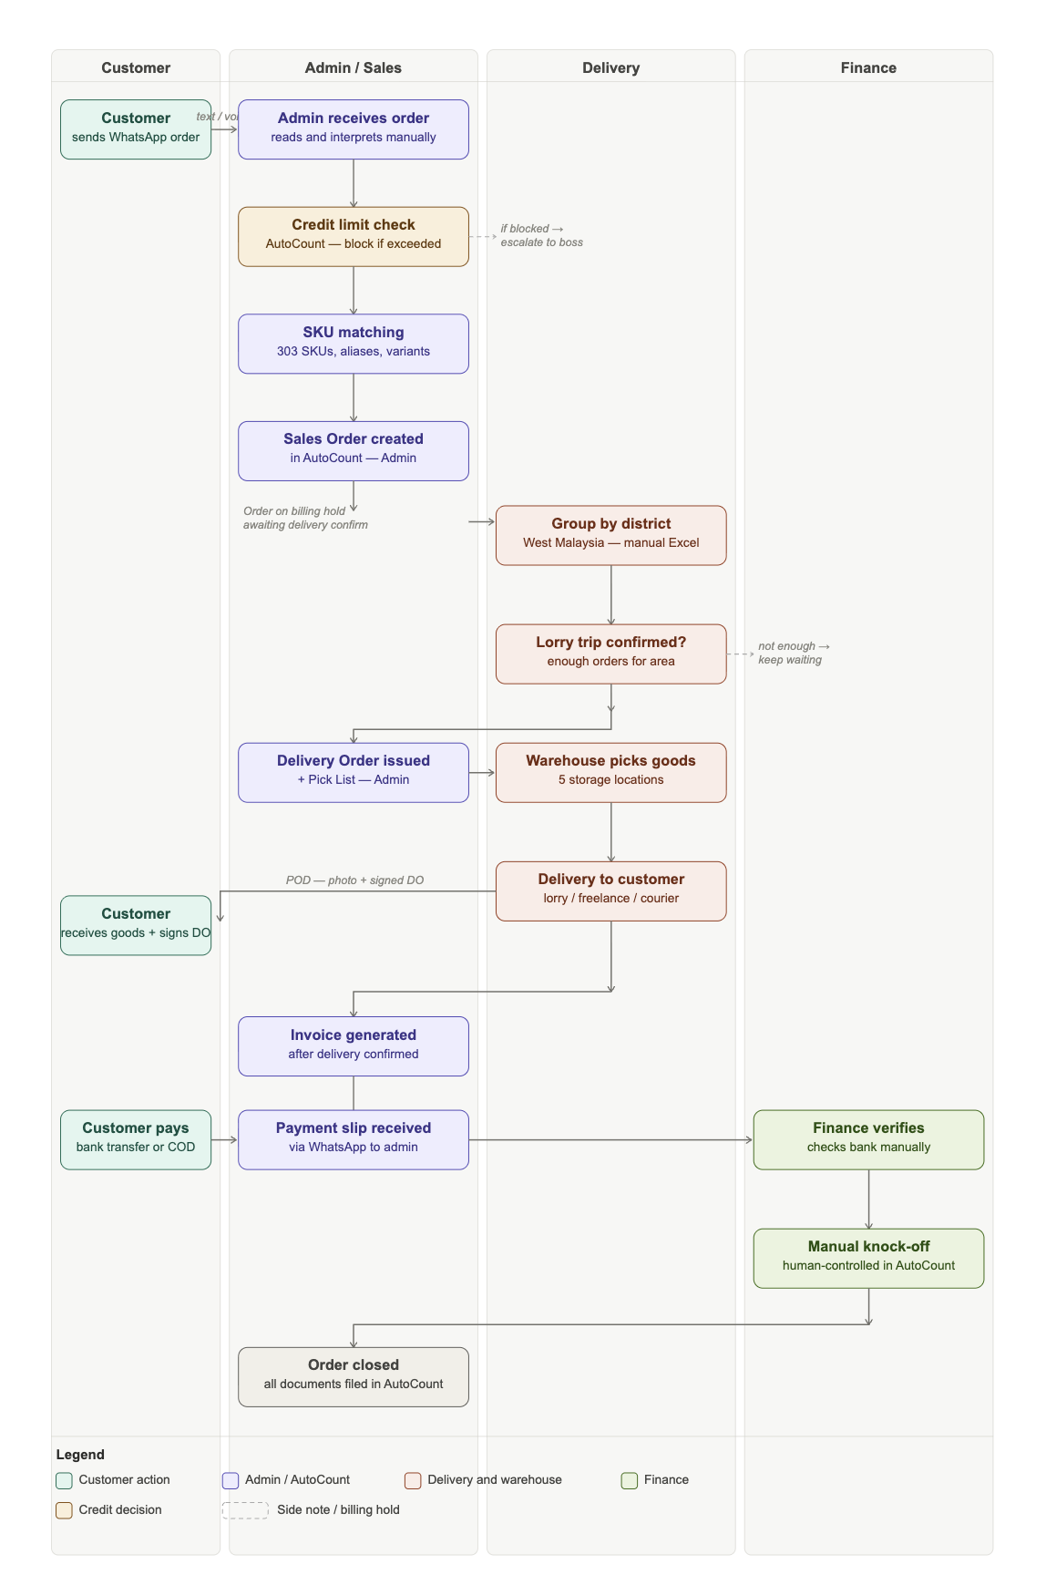

Section 1 — Business Structure
We need to understand whether DIY Ventures operates as a single entity or has related companies, as this affects how AutoCount data is structured and how MAIA filters records.
1.1 How many legal entities or companies are in your group? List all, even if they will not use MAIA immediately.
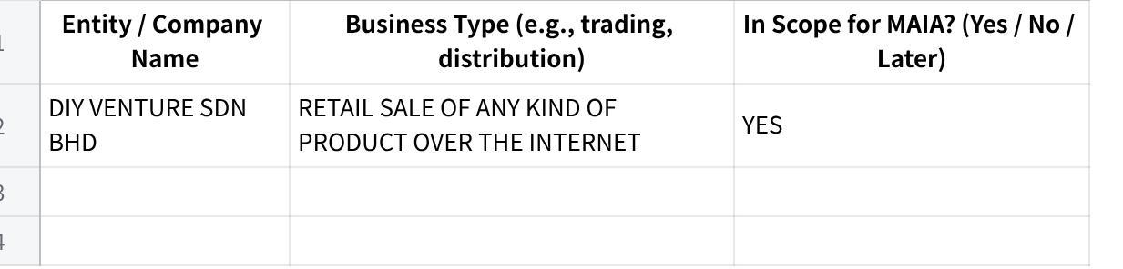
Click the image to view the sheet.
1.2 Do all entities share the same AutoCount installation and database, or does each entity have its own?
Your answer: ONLY ONE FOR DIY VENTURE SDN BHD
1.3 Do the entities share the same customer list and item/SKU list in AutoCount, or are these maintained separately per entity?
Your answer: NO
1.4 How many warehouses or stock locations does your business operate? List them below.
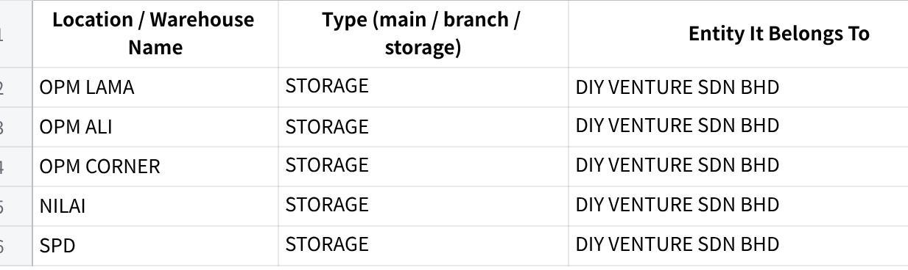
Click the image to view the sheet.

Section 2 — Team & Roles
2.1 How many people in your company will use MAIA day-to-day? (Approximate is fine.)
Your answer: 8
2.2 What roles will use MAIA, and roughly how many people per role?
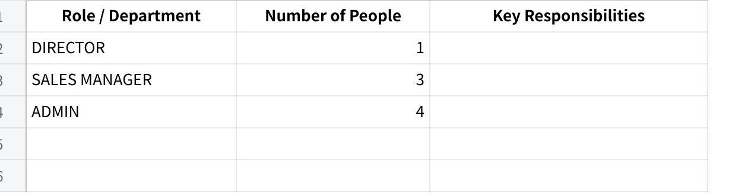
Click the image to view the sheet.
2.3 What are your standard operating hours? Do you operate on weekends or public holidays?
Your answer: MON-FRI 9AM-6PM, SAT 9AM-2PM
2.4 Who in your team currently handles WhatsApp orders end-to-end? (This person is the primary MAIA user in Phase 1.)
Your answer: ADMIN

Section 3 — AutoCount & Systems
This section is critical for integration planning. MAIA will treat AutoCount as the primary reference for customers, items, pricing, stock, and billing documents. Please answer as specifically as possible.
3.1 AutoCount details:
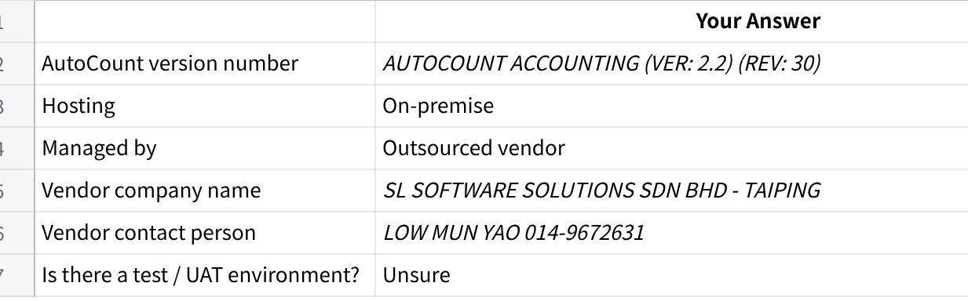
Click the image to view the sheet.
3.2 Have you done any previous integration or API project with AutoCount? (e.g., connecting it to another system, enabling API access) If yes, describe briefly.
Your answer: NO
3.3 Are there any non-standard customisations in your AutoCount? (e.g., custom report templates, custom approval workflows, special data fields) If yes, describe briefly.
Your answer: NO
3.4 Does each AutoCount user have their own login, or do multiple staff share a single account?
Your answer: OWN LOGIN
3.5 What other tools or systems do you use alongside AutoCount? (Please fill in all that apply.)
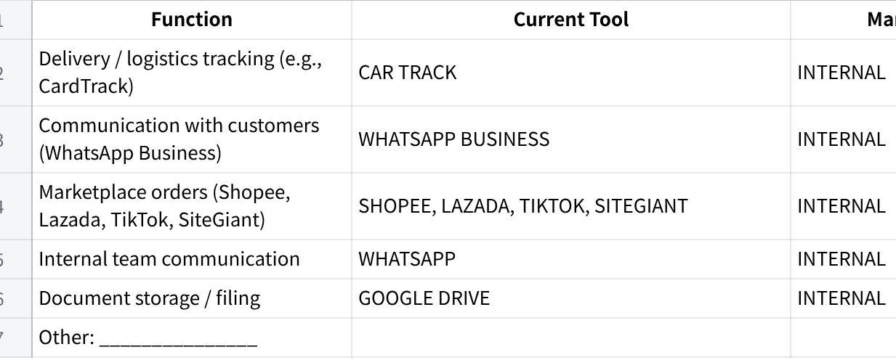
Click the image to view the sheet.

Section 4 — Products, SKUs & Pricing
DIY Ventures operates on standard SKU-based catalog ordering. MAIA needs to match informal customer language (e.g., WhatsApp messages) to your exact SKUs. This section helps us understand your catalog structure and pricing setup.

Products & SKUs
4.1 Approximately how many active SKUs / items do you carry in AutoCount?
Your answer: 303
4.2 How often are new items added or existing items retired? (e.g., rarely, monthly, frequently)
Your answer: rarely
4.3 Do you use product categories or groupings in AutoCount? If yes, list the main categories.
Your answer: Item group
4.4 Which of the following apply to your products? (Check all that apply.)
- [/] Multiple units of measure (e.g., sold by piece but stocked in cartons, sold by roll but received in bulk)
- [/] Product variants (e.g., different sizes of the same packaging material)
- [/] Bundle / kit products (one SKU = multiple components)
- [/] Items that customers commonly refer to by informal names or aliases (e.g., "big bubble wrap" instead of the SKU code)
4.5 Can you provide a list of common customer-facing aliases or informal names for your products? (e.g., what customers typically say in WhatsApp vs. your actual SKU name) This is important for MAIA to accurately match orders.
Your answer:
4.6 Do you manage stock separately across multiple warehouse locations? If yes, is the stock split visible inside AutoCount?
Your answer: yes

Pricing
4.7 How do you manage pricing? (Check all that apply.)
- [/] One standard price list for all customers
- [ ] Multiple price lists / tiers for different customer segments
- [/] Customer-specific pricing (negotiated per customer, stored in AutoCount)
- [ ] Volume-based or quantity-based discounts
- [/] Other: Agent specific pricing
4.8 Where is pricing data currently maintained? (Check all that apply.)
- [/] Inside AutoCount (price lists per customer or per tier)
- [ ] In a separate spreadsheet / Excel file
- [ ] In the admin's memory / experience
- [ ] Other: _______________
4.9 How frequently do selling prices change? (e.g., rarely, monthly, tied to supplier cost changes)
Your answer: Every month will have new catalogue so pricing will update

Section 5 — Order Intake & Workflow
Phase 1 focuses on WhatsApp and offline direct orders only. Marketplace orders (Shopee, Lazada, TikTok, SiteGiant) are not in Phase 1 scope.
5.1 How do customer orders typically arrive in Phase 1? (Check all that apply.)
- [/] WhatsApp text message
- [/] WhatsApp voice message
- [/] Purchase Order (PO) document sent via WhatsApp (PDF, image, or Excel)
- [/] Phone call / offline (staff keys it in manually)
- [/] Walk-in / counter
5.2 Approximately how many orders do you process per day, and per month?
Click the image to view the sheet.
5.3 How many line items does a typical order contain? (e.g., 1–3 items, 5–10 items)
Your answer:
5.4 Who creates the order or bill in AutoCount once an order is received?
Your answer: ADMIN
5.5 Is there an approval step before an order is confirmed and billed? If yes, who approves and under what circumstances?
Your answer:
5.6 Do you handle repeat orders where a customer says something like "same as last time" or "same as previous order"? If yes, how do you currently handle this?
Your answer: Yes, send the customer the new catalogue and use the new price.
5.7 Do customers ever send orders in mixed language (e.g., Mandarin + English in the same message)? How do you handle this today?
Your answer: Yes
5.8 Do any of the following scenarios occur? (Check all that apply.)
- [/] Customer sends a handwritten or printed PO photo
- [/] Customer sends an order but delivery cannot be confirmed yet — order is held
- [ ] Customer places an order but has an outstanding unpaid balance — staff checks before proceeding
- [ ] Customer asks for a price check before placing a formal order
- [ ] Staff need to flag a rare custom/non-catalog item for manual handling

Section 6 — Delivery & Grouping
Note: MAIA Phase 1 supports district/area grouping and billing hold status. Lorry fullness calculation, route optimisation, and GPS/CardTrack integration are not in Phase 1 scope.
6.1 How do you deliver goods to customers? (Check all that apply.)
- [/] Own lorry / in-house drivers
- [/] Freelance / contract drivers
- [/] Third-party courier / logistics company
- [/] Customer self-pickup
- [ ] Other: _______________
6.2 How do you currently group orders for delivery? (e.g., by district, by area, by lorry trip, manually using Excel or a list)
Your answer: by district, by area, by lorry trip, manually using Excel
6.3 What districts or delivery areas do you currently serve? Please list them. (This is needed for MAIA to tag and group orders correctly.)
Your answer: ALL STATES OF WEST MALAYSIA
6.4 What is your current process for deciding when a lorry trip is confirmed and ready to go? (e.g., enough orders for an area, boss decides, fixed schedule)
Your answer: Enough orders for an area
6.5 Is the delivery order / delivery note issued before or after the lorry trip is confirmed?
Your answer: DELIVERY ORDER ISSUED AFTER THE LORRY TRIP IS CONFIRMED
6.6 Do drivers currently capture proof of delivery (POD)? If yes, how? (e.g., photo, customer signature, paper)
Your answer:YES, PHOTO AND DO SIGNED

Section 7 — Finance, Payment & Credit
Note: MAIA will capture and route payment proof to finance for verification. Automatic payment knock-off is not in Phase 1 — all knock-off remains human-controlled.
7.1 What payment methods do your customers use? (Check all that apply.)
- [/] Bank transfer (customer sends receipt via WhatsApp)
- [/] Cash on delivery (COD)
- [ ] Cash payment at counter / office
- [ ] Cheque
- [ ] Credit terms (customer pays later — net 7, net 30, etc.)
- [ ] Other: _______________
7.2 How do customers typically notify you when they have made a payment? (e.g., WhatsApp payment slip to admin, WhatsApp to salesperson, no notification — finance checks bank)
Your answer: WhatsApp payment slip — finance checks bank
7.3 Do you extend credit terms to customers? If yes, what are your standard credit terms? (e.g., 7 days, 30 days, 60 days)
Your answer: NO
7.4 Do you set credit limits per customer in AutoCount? What happens when a customer exceeds their credit limit? (e.g., order blocked, manager approval required, warning shown, nothing)
Your answer: YES, order blocked, warning shown
7.5 Is credit limit enforcement currently managed inside AutoCount or tracked manually?
Your answer:YES
7.6 What is your e-invoicing (LHDN MyInvois) status?
- [ ] Already live and automated (auto-sync to LHDN)
- [ ] Live but manual submission
- [ ] In progress
- [/] Not yet started
- [ ] Not applicable

Section 8 — Documents
MAIA will prepare order and billing documents in AutoCount format. We need to confirm which documents are used in your Phase 1 workflow.
8.1 Which of the following documents are currently used in your order-to-billing workflow?
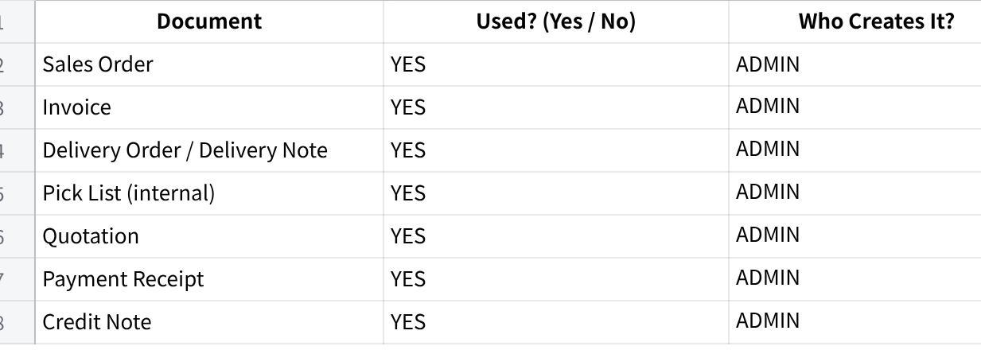
Click the image to view the sheet.
8.2 When is the Sales Order created relative to delivery — before or after the lorry trip is confirmed?
Your answer: before the lorry trip is confirmed
8.3 When is the Invoice generated — at the same time as the Sales Order, or after delivery is confirmed?
Your answer: After delivery is confirmed
8.4 Are there any specific fields or references your documents must include? (e.g., customer PO number, delivery area tag, specific layout) Write "to discuss" if easier to show in the meeting.
Your answer: TO DISCUSS
8.5 Are your document templates built using AutoCount's standard report engine, or have they been customised by your vendor?
Your answer: AUTOCOUNT TEMPLATES

Section 9 — WhatsApp & Language
MAIA's Phase 1 workflow is built around WhatsApp-based order intake. This section helps us configure MAIA for your specific WhatsApp setup and language environment.
9.1 Do you have a WhatsApp Business account for receiving orders? If yes, is it a standard WhatsApp Business app or WhatsApp Business API (WABA)?
Your answer: YES, standard WhatsApp Business app
9.2 How many WhatsApp numbers does your team currently use to receive orders? (e.g., one company number, multiple staff numbers)
Your answer: 2
9.3 Would your staff forward or input customer orders into a separate MAIA assistant number, or do you prefer MAIA to be integrated directly into your existing WhatsApp number?
Your answer: TO DISCUSS
9.4 What languages do your staff use when processing orders internally? (Check all that apply.)
- [/] Mandarin (most common)
- [/] English
- [/] Bahasa Malaysia
- [/] Mixed Mandarin + English
- [ ] Other: _______________
9.5 What languages do your customers communicate in when placing orders? (Check all that apply.)
- [/] Mandarin (most common)
- [/] English
- [/] Bahasa Malaysia
- [/] Mixed Mandarin + English (likely)
- [/] Malaysian informal phrasing
- [ ] Other: _______________
9.6 Do any customers send orders as voice messages? If yes, approximately what percentage, and in which language(s)?
Your answer: YES

Section 10 — Pain Points & Priorities
10.1 What are the top 3 problems you want MAIA to solve? (In your own words — be as specific as possible.)
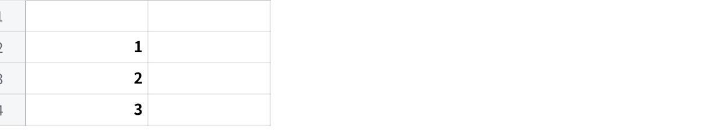
Click the image to view the sheet.
10.2 What currently takes the most time in your daily operations that you wish was faster or easier?
Your answer:
10.3 Is there anything that currently "falls through the cracks" — orders missed, billing delayed, follow-ups forgotten?
Your answer:
10.4 If MAIA could only do one thing for your business, what would it be?
Your answer:
10.5 Is there anything your team currently does outside AutoCount — in WhatsApp, Excel, paper, or memory — that you believe should be in a proper system?
Your answer:

Section 11 — Data Readiness
MAIA needs reference data from AutoCount to function correctly. The items below are required before build can begin. Please indicate what you can provide and when.
11.1 Can you provide the following data in Excel or CSV format?
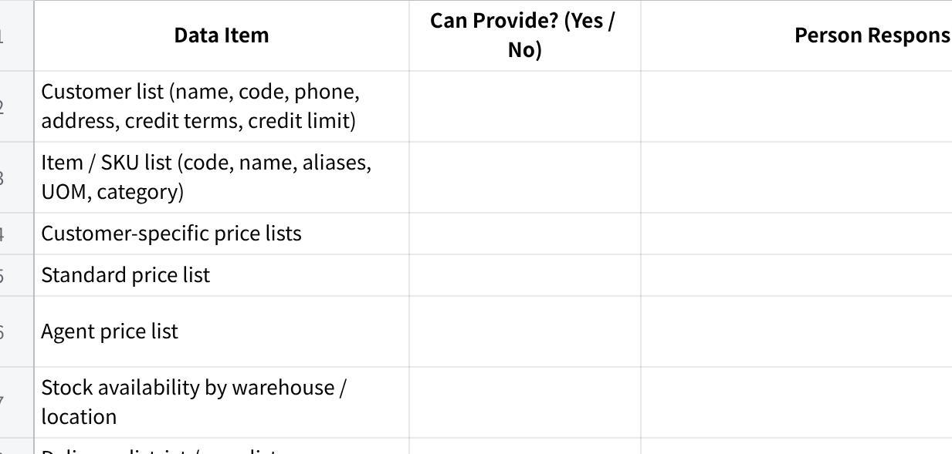
Click the image to view the sheet.
11.2 Do you want historical transaction data (past orders and invoices) to be available inside MAIA, or are you comfortable starting fresh from go-live onwards?
- [ ] Forward-only — new transactions from go-live onwards (standard)
- [ ] Want historical data available — approximate date range: _______________
- [ ] Unsure — to discuss
Note: Historical data migration is a separate scope item. Feasibility and cost will be assessed based on data volume and quality.

Section 12 — Hosting & Infrastructure
MAIA will be deployed in DIY Ventures' own cloud/server environment. Hosting and infrastructure costs are the client's responsibility. We need to confirm technical access details before build begins.
12.1 What is your current hosting or cloud environment? (e.g., local server, AWS, Azure, Google Cloud, shared hosting)
Your answer:
12.2 Is AutoCount hosted in the same environment, or on a separate server?
Your answer:
12.3 Who will provide server access and coordinate with your IT vendor during setup?
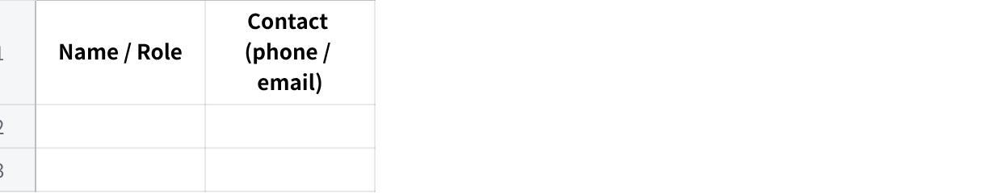
Click the image to view the sheet.
12.4 Are there any security or data separation requirements we should be aware of? (e.g., data must stay on-premise, specific firewall rules, VPN access required)
Your answer:

Section 13 — Timeline & Project Ownership
13.1 When do you need MAIA to be operational? Is there a specific deadline or target date?
Your answer: WITHIN A MONTH
13.2 Who from your team will be the internal project owner — the day-to-day contact during onboarding? (Ideally someone operational who handles orders daily, not only a department head.)
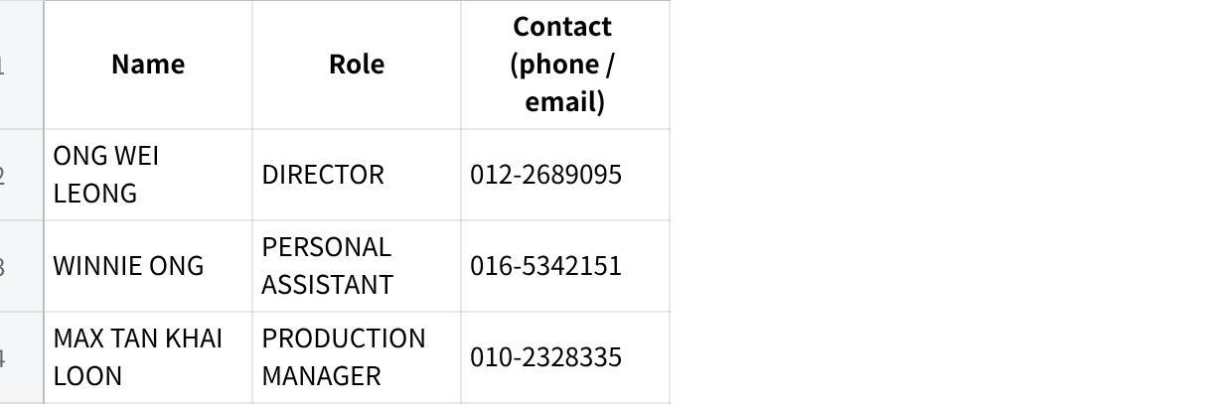
Click the image to view the sheet.
13.3 Who will be the final decision-maker if approvals are needed during setup? (e.g., for workflows, permissions, scope decisions)
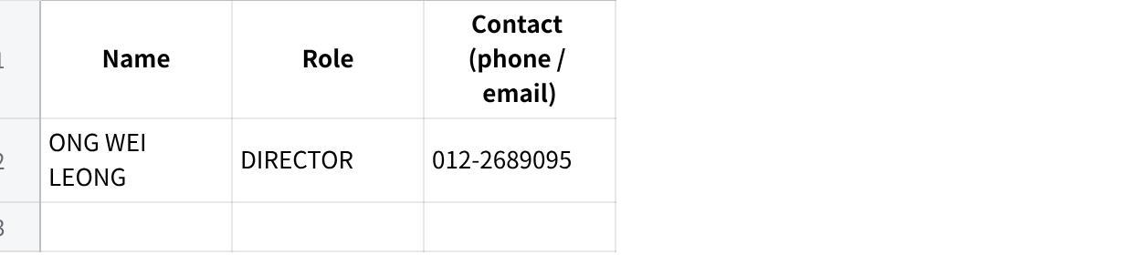
Click the image to view the sheet.
13.4 Are there any upcoming events that might affect your team's availability during onboarding? (e.g., peak season, public holidays, staff travel, audit)
Your answer:

What Happens Next
Once you return this questionnaire and the sample data items listed in Section 11, we will:
- Review your responses and prepare a focused agenda for the kick-off meeting.
- Schedule Meeting 1 (business workflow deep-dive) — approximately 1.5 to 2.5 hours.
- Schedule Meeting 2 (IT/integration scoping with your AutoCount vendor if required)
- Begin data collection and AutoCount access setup in parallel.
Please return this document to: Brendan
Questions about any item? Do message us in the group chat. We're happy to clarify.

MAIA by Mindhive — DIY Ventures Onboarding Questionnaire

